Project: Microgeneration Readiness Advisor – Phase 3 Report

General Information
- Team Members: Balkaran Singh Jaswal
- Date: July 14, 2026
- Git Repository Link: https://github.com/BalkaranJ/Microgeneration-Advisor

Part A: Describe Object-Oriented Design Principles
Definition of OOD Principles
I built the advisor on the core object oriented ideas so the codebase stays clean as it grows. Encapsulation means each object hides its own data and exposes it only through methods, so nothing outside can put an object into a bad state. Abstraction means I define what a job is before I say how it is done, which is how the abstract scorer names the scoring contract without locking in one formula. Inheritance lets a concrete class take that contract and fill in the details, which is what the solar scorer does. Polymorphism lets the rest of the code hold a scorer through its contract and call it the same way no matter which concrete scorer it is.
On top of these I use two well known design patterns and one safety habit. The Strategy pattern treats each scoring approach as an interchangeable object behind the abstract scorer, so a new approach can be added or swapped without touching the caller. The Facade pattern gives the whole system a single simple entry point through the readiness advisor, so the interface does not need to know the many steps behind an assessment. And a custom exception type carries input problems to one clear place instead of letting the program crash.
Application to Project:
These principles push the design toward scalability, maintainability, and extensibility in concrete ways. Because validation lives inside the project object, every input is checked in one place, so adding a new rule touches one file rather than many. Because scoring sits behind an abstract contract, I can refine the solar formula, or add a second calculation such as a roof adjusted score, without rewriting the parts that call it.
Because the readiness advisor is a facade, the user interface only ever calls one method and stays unaware of the bill reading, the weather pull, the roof read, the sizing, and the scoring behind it. That separation is what lets the same core serve very different front ends, and it lets the planned solar features slot in behind the facade rather than spreading through the whole app.

Part B: Describe Class Collaborations and Hierarchies
Key Class Relationships:
The design uses several kinds of relationship. Inheritance connects the concrete SolarSuitabilityScorer up to the abstract SuitabilityScorer, so the solar scorer is a kind of scorer and must honour the same contract. Composition connects the ReadinessAdvisor to the helpers it creates and owns, its scorer, its classifier, its planned system sizer, and its planned vendor directory, since those helpers live and die with the advisor.
Association and dependency connect the parts that are handed in or called rather than owned. The advisor is given a MicrogenerationProject and a WeatherProfile that are built outside it, which is a looser association. The advisor and the scorer depend on the data objects they read, and the FastAPI layer depends on the advisor and the weather service. The planned adapters, the bill parser, the roof analyzer, and the generation estimator, each produce a data object that the rest of the system then reads.
Collaborations Summary:
The classes collaborate in one clear line. The React interface gathers the uploaded bill and the address and posts them to the FastAPI layer. The layer hands the request to the readiness advisor, which parses the bill for yearly usage, gets the location and a full year of weather, reads the roof for facing and panel fit, sizes the system, estimates the yearly generation, scores solar suitability, and builds the verdict, the checklist, and the vendor list. It returns one plain result that the interface renders.
The key to the modularity is that the core scoring package knows nothing about HTTP or React. It works only with plain data objects and its own helpers, so it can be tested on its own and reused unchanged. That is exactly what happened when the project moved from a Streamlit interface to the React and FastAPI stack, and it is why the planned solar helpers can be added behind the same facade without disturbing the interface.

Part C: Create UML Diagrams
Class Diagram:
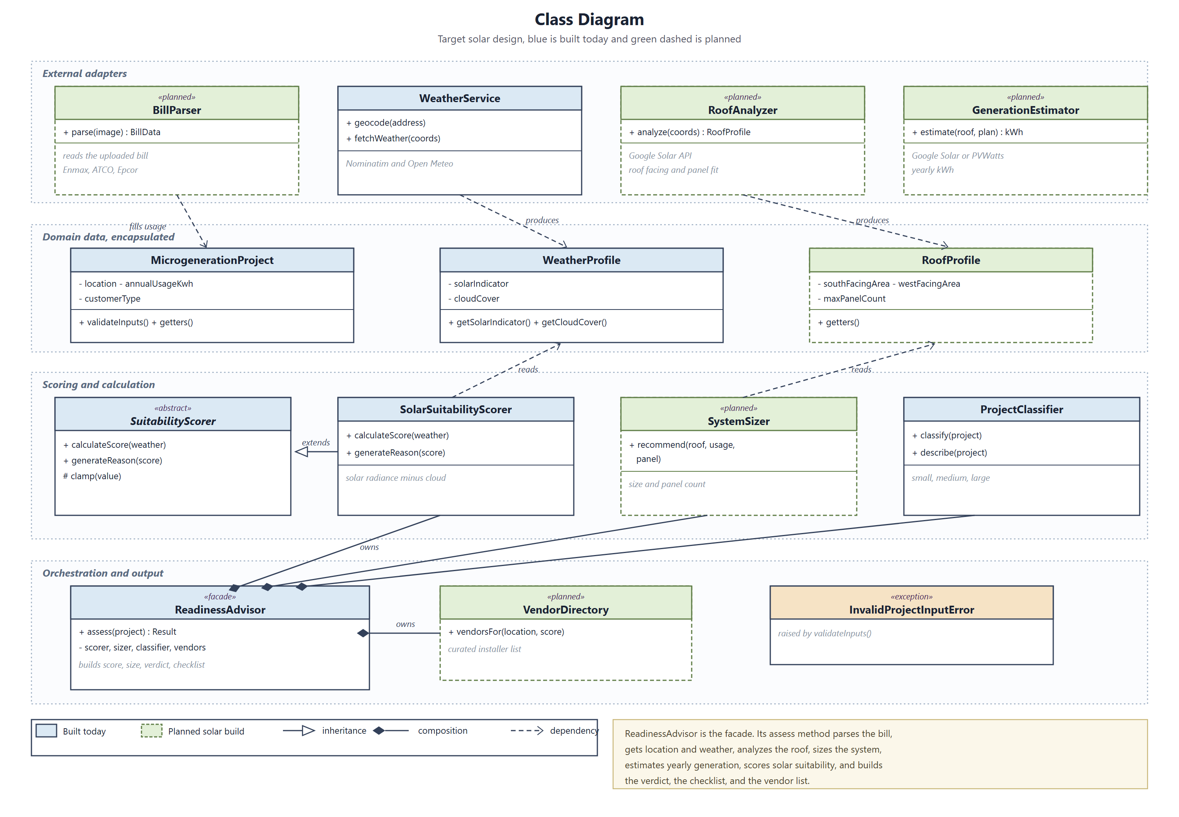
Use Case Diagram:
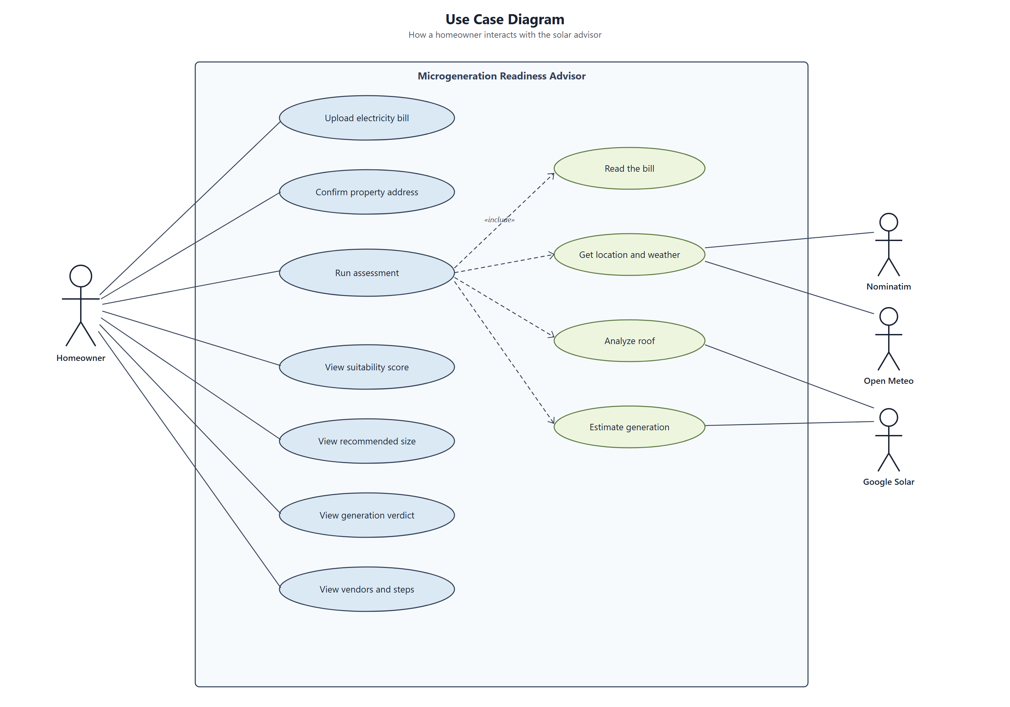
(Optional) Sequence Diagram:
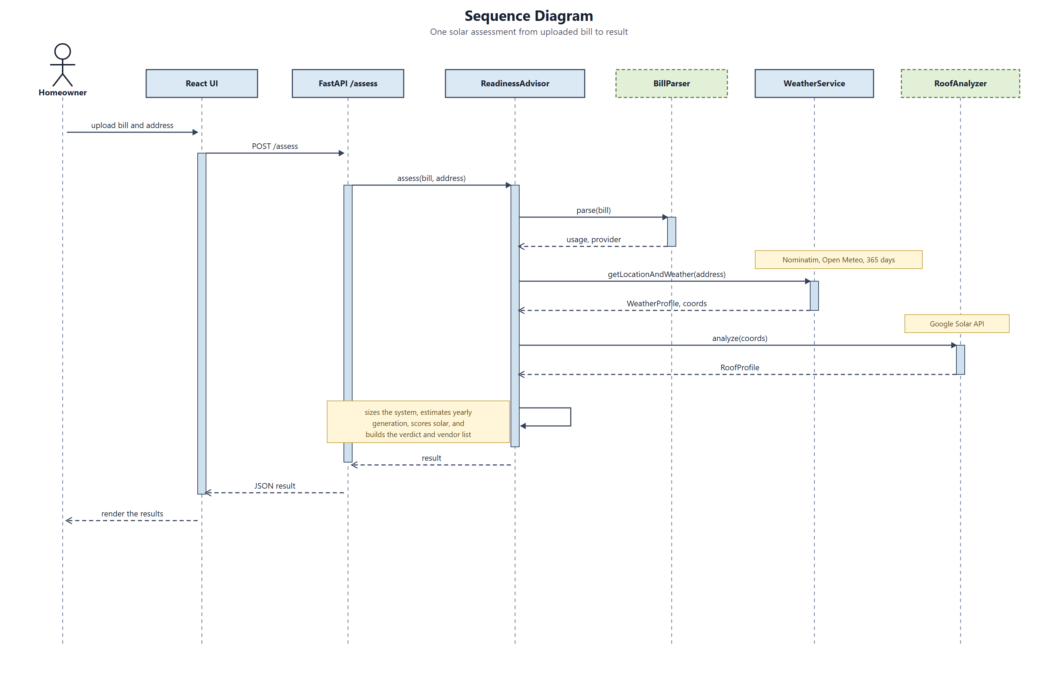
Explanation:
The class diagram groups the classes into four bands, the external adapters that wrap outside services, the encapsulated data objects, the scoring and calculation classes, and the orchestration layer with the facade at its centre. Blue classes exist in the prototype today and green dashed classes are the planned solar build, so the diagram doubles as a roadmap.
The use case diagram shows the homeowner uploading a bill, confirming an address, running the assessment, and viewing the score, the recommended size, the generation verdict, and the vendors, with the outside services drawn as supporting actors. The sequence diagram follows a single request from the uploaded bill through the advisor as it calls each helper in turn and returns one plain result.

Part D: Evaluate OOD Impact
Maintainability and Scalability Analysis:
Looking back at how the design behaved, the object oriented choices paid off in ways I can point to. The facade was the clearest win. When I replaced the entire Streamlit front end with a React and FastAPI stack, the scoring classes did not change at all, because the interface only ever depended on one assess method. The same core served two very different front ends.
The abstraction around scoring paid off when the product narrowed to solar. The wind scorer was one strategy behind the abstract scorer, and removing it touched only the wiring, not the interface or the data objects. The same shape now lets the planned solar features, the roof read, the sizing, the generation estimate, and the verdict, slot in behind the facade, so growing the analysis does not ripple outward. Encapsulated validation kept bad input, such as a zero usage figure, contained in one place so the app showed a clear message instead of crashing, which the unit tests confirm.
Trade-offs or Challenges:
The design is not free. For a tool this small, the abstract base and the facade are more structure than a single script would need, and that extra structure only earned its keep once the front end changed and the feature set grew. During the move from Streamlit to the new stack I kept two copies of the core for a while, which risked the two drifting apart, and the right next step is to fold them into one shared module.
There is also an honest gap between the design and the code today. Several of the classes in the diagram, the bill parser, the roof analyzer, the system sizer, the generation estimator, and the vendor directory, are planned rather than built, so the abstraction that will hold them is proven in shape but not yet exercised at full size. With only solar in place, the scorer abstraction also carries a single concrete strategy for now, so some of its value stays in reserve until more calculations are added.

Part E: Shell Scripting for Automation
Script 1:
- Purpose: runs the unit test suite and prints a short summary of how many tests passed and failed
- Key Features Used: variables for the project root and the interpreter, a pipe from pytest into grep and awk to tally the results, and sed to trim the test names
- How to Run: bash Phase3/scripts/run_tests.sh from the repository root
Script 2:
- Purpose: prints a snapshot of the code structure, the classes, the method and line counts per file, and the most common method names
- Key Features Used: grep to find the class and def lines, awk to count and format the table, sed to strip the keywords, sort and uniq to rank names, and variables for the file list and the patterns
- How to Run: bash Phase3/scripts/project_report.sh from the repository root
Git Repository Link: https://github.com/BalkaranJ/Microgeneration-Advisor

